Name:

Year 9 Science Revision 2022
- Complete the following table about sub-atomic particles (parts of an atom):
Name of particle | Location of particle in an atom | Electric charge of particle | Relative size of particle.  (Ie largest or smallest)
Proton

 | The nucleus of the atom |  | Equal largest
 |  |  | The smallest particle in an atom

- What is the difference between an element and a compound?

- What is the difference between an ion and an atom?

- When magnesium is burned, the magnesium combines with oxygen to form a white substance called Magnesium Oxide
  - List the reactants of the chemical reaction described above:

  - List the products of the chemical reaction described above:

  - Write the word equation for the reaction described above: (Use an arrow to separate reactants and products)

- Complete the following table which relates to the number of electrons that can fit into an electron shell of an atom:
Shell position from nucleus | Number of electrons that can fit in the shell
1st shell
2nd shell
3rd shell

- Draw the arrangement of electrons around the following atoms: Potassium (19 electrons)
Fluorine (9 electrons) Sodium (11 electrons)
F
Na
K

- The word equation for igniting hydrogen gas in air (oxygen) is:

Hydrogen + Oxygen Water

List the product/s:

List the Reactant/s:

- State the law of conservation of mass.

- What is the difference between endothermic and exothermic chemical reactions?

___________________________________________________________________________________
- Use the periodic table and your knowledge from class to complete the following table:
The first one has been completed for you.

Element | Symbol | Atomic Number | Atomic Mass | Number of Protons | Number of Neutrons
Magnesium | Mg | 12 | 24 | 12 | 12
 | O |  |  | 8 | 8
 |  | 16 | 32
 |  |  | 27 |  | 14
 |  |  | 4 | 2

- Read the following passage describing a chemical reaction that you did in class:

Potassium Iodide and Lead Nitrate are both clear liquids. When they are added together the liquid instantly turned bright yellow. This is due to a substance called Lead Iodide being formed along with another substance called Potassium Nitrate.
- List the products of the reaction:
- List the reactants of the reaction:
- Write a word equation (using an arrow to separate the reactants and the products) for the chemical reaction:

- Fill in the missing name and chemical diagram for the following chemical reaction:

Copper + Hydrogen Sulphate Copper Sulphate +
S
O
O
O
S
O
O
O
Cu
H
H
Cu

- Your friend made excellent revision notes on Radiation, but you notice they have left out what the Alpha, Beta particles are comprised of. Add the following terms to the diagram;
- 2 protons and 2 neutrons
- Electron
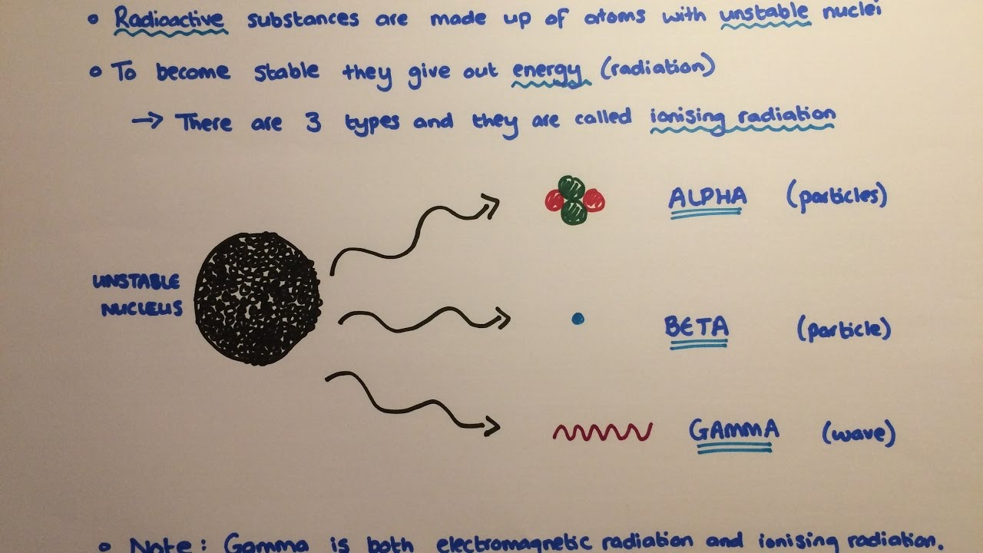
Using the information from the notes above. Explain the following diagram in the space provided below.



